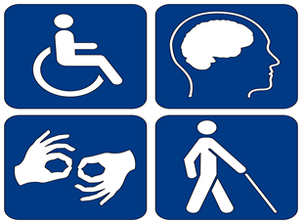
Accommodating for Success
Scouting supports and promotes full inclusion. Most Scouts with disabilities participate in traditional units in their local communities. Some, due to family choice, peer group, or specialized needs or interests might join a special needs unit. In either environment, thoughtful planning and cooperation can ensure success along the Scouting path.

Accommodations are
individual,
situational,
and task-specific.

The needs of the Scout and the desired outcomes are the starting points. Unit activities not related to rank and advancement requirements allow for greater flexibility. Other situations might need to be accommodated in reference to the current Guide to Advancement.

Creativity, communication, planning, and follow-through are the hallmarks of creating a successful Scouting journey.

Looking for Support?

Delivering the Scouting program to any Scout can be tremendously rewarding for volunteer leaders. While each Scout is unique, extra challenges might present themselves when working with Scouts with differing abilities and special needs. The BSA, along with the National Special Needs and Disabilities Committee, has compiled resources for unit, district, and council volunteers and professionals, to assist in including youth of all abilities in Scouting.

General Interest
www.scouting.org/resources/disabilities
Able Scouts: ablescouts.org
Inclusion Toolbox: ablescouts.org
Abilities Digest: facebook.com/abilitiesdigest

Advancement
Guide to Advancement:
www.scouting.org/resources/
guide-to-advancement
Refer to sections on Rank, Merit Badges, Registration, and Individual Scout Advancement Plan

Seeking Inspiration?

The National Special Needs and Disability Committee has developed an online reference tool. The Inclusion Toolbox is an easy-to-use, searchable, and updatable source. Created in collaboration with a wide range of medical, educational, and special-needs experts, it provides information related to specific disabilities and Scouting concerns. This is the place to go if you have questions. Find ideas for supporting the needs of Scouts with differing abilities. Discover ways to address camping, health, safety, waterfront, organizational, and many more Scout-related concerns.

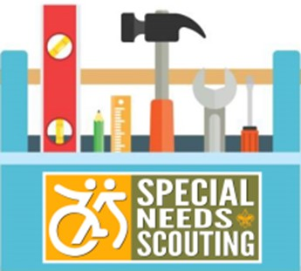

Inclusion Toolbox

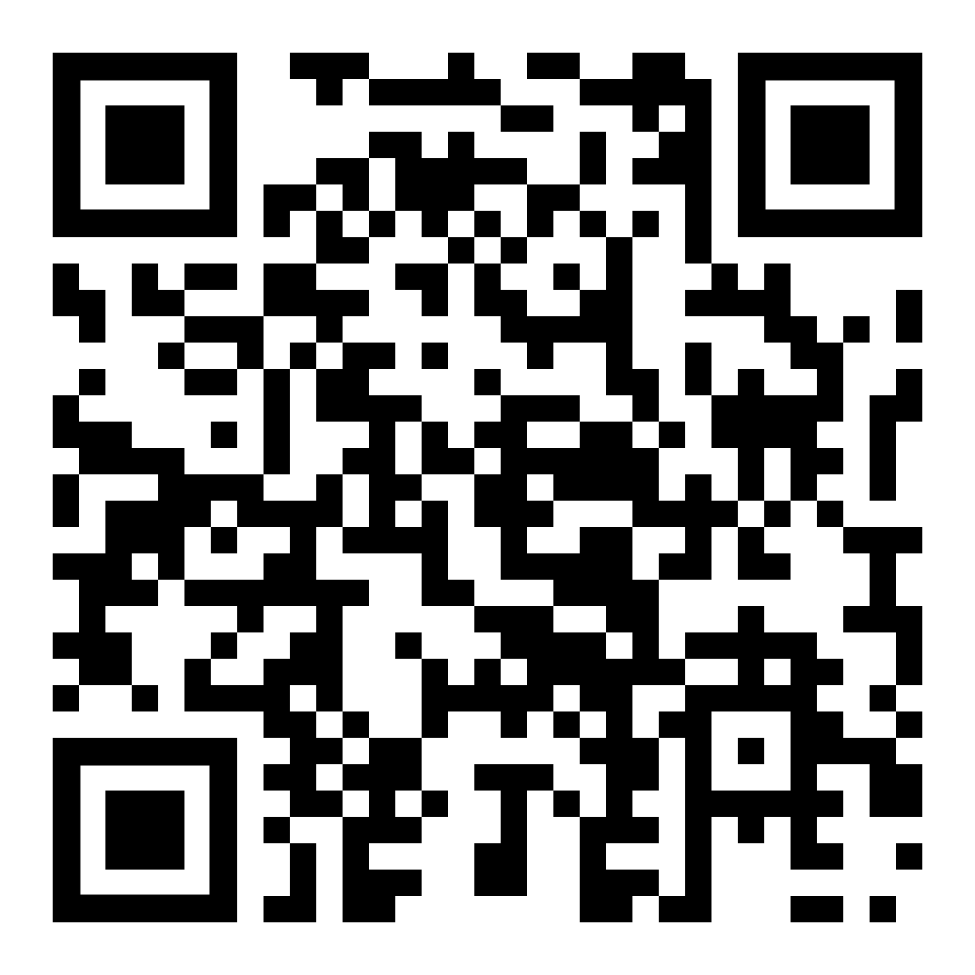

Why Join Scouting?

Scouts BSA is one of the nation’s
preeminent values-based youth development organizations.

It provides growth opportunities for:
Character building,
Citizenship and Service
Interest-based skills
Physical fitness,
Leadership,
Social skills,
STEAM

Since 1910 the BSA has helped to enhance the lives of individuals, families, and communities by combining educational activities and lifelong values with fun.

Guided by the Scout Oath and Scout Law,
it is the vision of the BSA to prepare every eligible youth in America (regardless of gender) to become the best, most responsible citizen they can be.

Involvement in Scouts BSA programs contributes to building a more responsible, productive, and inclusive society.
You are invited to join!
Interested? Have Questions?
Please Contact

SCOUTING AMERICA LONG ISLAND
544 Broadway
Massapequa, New York 11758
516 797-7600

Michael Malloy, Council President
Christopher Coscia, Scout Executive
Susana Isaacson, A.C.S.W. Chair SNS

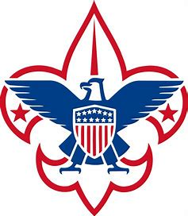

BSA National Special Needs and
Disabilities Committee
www.scouting.org/rescources/
disabilities-awareness
specialneedschair@scouting.org
Scout Us All In!

Join us for
Lasting Friendships
Fun and Adventure
Character Development
Skills and Learning
Family Fun

A History of Inclusion
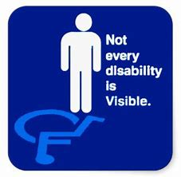
The BSA is a values-based youth development program that has included youth with emotional, mental, and physical disabilities since its founding. We continue to be committed to expanding resources that support a successful Scouting journey for youth with both visible and invisible disabilities. Environmental adaptations, varied instructional methods, and mindful planning can support meaningful participation in
Scouting starting at age five through adulthood as appropriate.

National Special Needs and Disabilities Committee — Boy Scouts of America
www.scouting.org/rescources/
disabilities-awareness

